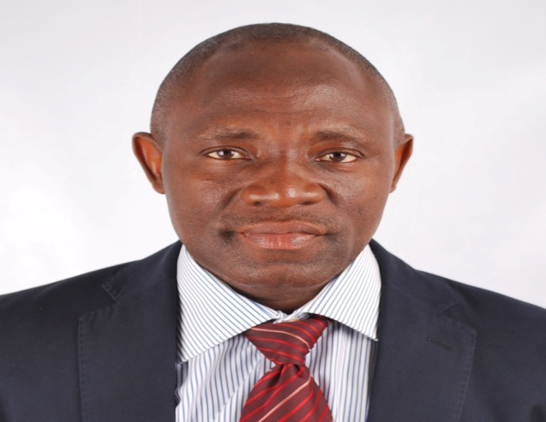

Name: KUYE, Owolabi Lateef
Designation: Professor
Qualifications: B.Sc (Ife), M.Sc., Ph.D. (Lagos)
Research Area: Strategic Management and Entrepreneurship
Professor O.L. Kuye is the former Dean of the Faculty of Management Sciences, University of Lagos, Nigeria. He was the Head of Department of Business Administration. He was a former Coordinator, Masters of Business Administration (MBA) programmes. He is a Member, The Academy of Management Nigeria. He is also a Member, Academy of Management (AOM), USA.
He was a member of the Board of School of Postgraduate Studies. He is a Fellow of the Nigerian Institute of Management (FNIM).

